**Considerations for large clusters**

A cluster is a set of [nodes](https://kubernetes.io/docs/concepts/architecture/nodes/) (physical or virtual machines) running Kubernetes agents, managed by the [control plane](https://kubernetes.io/docs/reference/glossary/?all=true#term-control-plane). Kubernetes v1.21 supports clusters with up to 5000 nodes. More specifically, Kubernetes is designed to accommodate configurations that meet *all* of the following criteria:

* No more than 110 pods per node
* No more than 5000 nodes
* No more than 150000 total pods
* No more than 300000 total containers

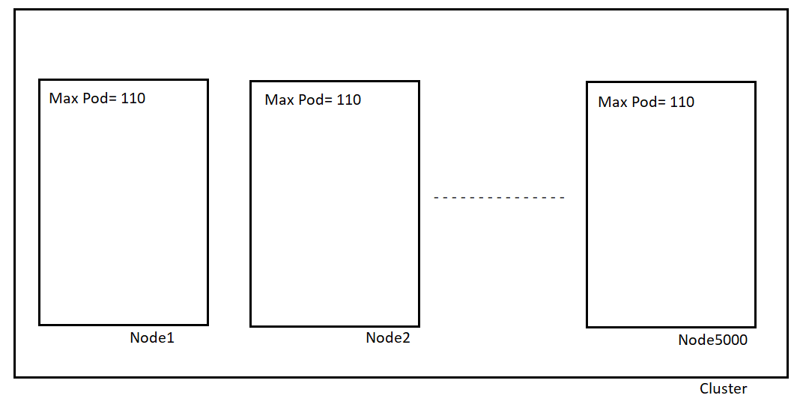

## Scheduling Process (Automated Placement)

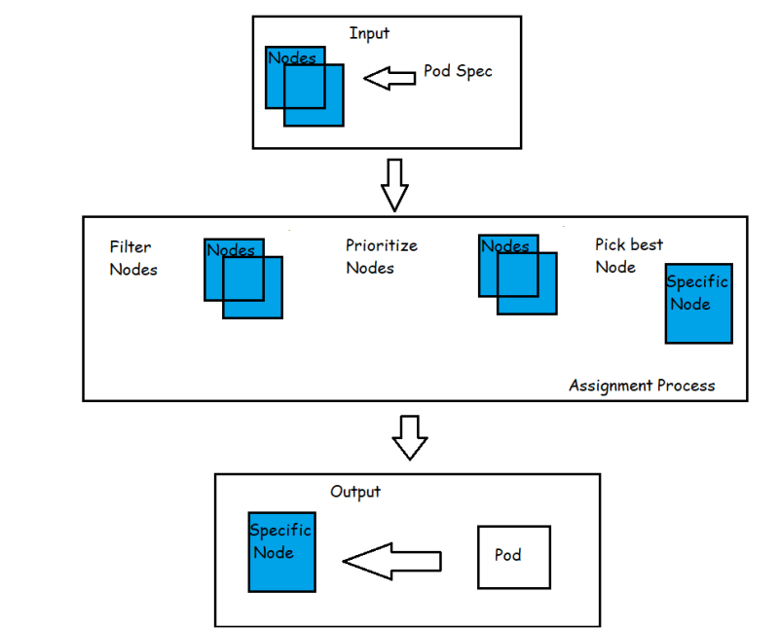

* As soon as pod is created that is not assigned to a node yet, it gets picked by scheduler together with all the available nodes and set of filtering and priority policies.
* In first stage, Scheduler tries to apply the filtering and priority policies by removing all the nodes that do not qualify the Pod’s criteria
* In Second stage, all the qualified nodes get ordered by weight
* In last stage Pod gets assigned to the node (highest weight)
* Node Selector:
  + This assignment can be done under node selector
  + NodeSelector is the Pod field and specifies a map of key values pairs that must be present on the node for the node to be eligible to run the Pod

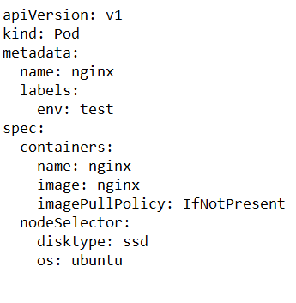

# Assign Pods to Nodes

# kubectl get nodes --show-labels

# 

# kubectl label nodes <your-node-name> disktype=ssd

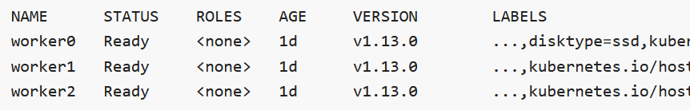

Node Affinity:

* + This feature is generalization of the node selector approach.
  + Node Affinity feature greatly expands the types of constraints that be expressed by providing operators
    - In
    - NotIn
    - Exists
    - DoesNotExist
    - Gt
    - Lt

